Name: Period:
Date:

This is not a perfect lesson plan, although it will provide you with an idea of what is expected for your week 3 assignment.

Functions: Pre-Assessment
Directions: Take your time and answer the following questions as best as you can. It is important that you try to answer each question.

- What is the definition of a function?

- What is an ordered pair? Can you show an example?

a. If Jake makes $45 a day plus an additional $2.50 for each pizza he delivers, how much will he make on a day where he delivers 10 pizzas?

  - Is this function represented algebraically, verbally, numerically, or graphically?

- In the following function, please underline the input and circle the output:

𝑦𝑦 = 3𝑥𝑥 + 2

5. a. Consider the function 𝒚𝒚 = 𝟐𝟐𝟐𝟐 − 𝟕𝟕. If 𝟐𝟐 = 𝟗𝟗, then what is 𝒚𝒚?

  - Is this function represented algebraically, verbally, numerically, or graphically?

6. Complete the following table:

𝟐𝟐 | 𝒚𝒚 = 𝟐𝟐^{𝟐𝟐} | 𝒚𝒚
-1 | 𝑦𝑦 = (−1)² | 1
0
1
2

What is the domain in this table?

What is the range in this table?

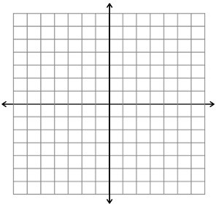

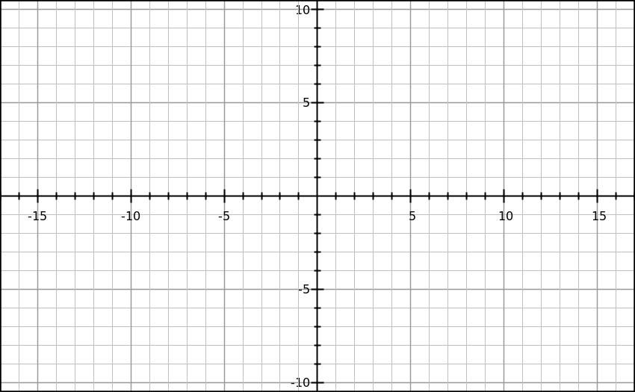
Graph and label the following points: H: (3, 7)
J: (0, 4)
K: (-1, 8)
M: (-3, -4)

- Consider the following data in the table
Minute | 1 | 2 | 3 | 4
Temperature | 125 | 123 | 121 | 119

Is the data linear or nonlinear?

Is the data increasing or decreasing?

Is this function represented algebraically, verbally, numerically, or graphically?

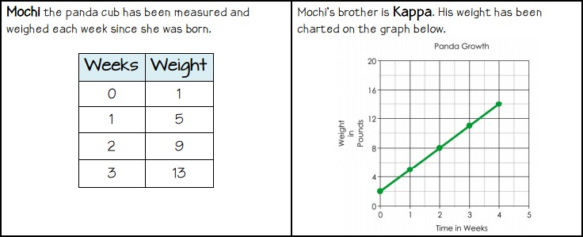

Which Panda is growing faster? How do you know?

Which of the following graphs is linear?
  - b) c)
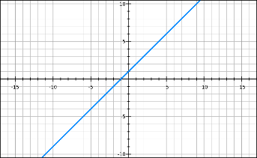
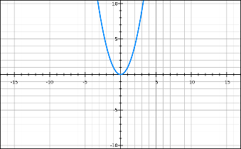
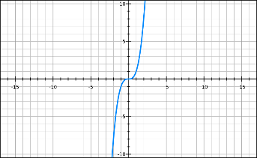

The following table shows the total number of people served at a fast food restaurant in one day. What is the rate of change? If the pattern continues, what will be the total number of people served by 5:00?

Time | Total Number of Customers Served
12:00 | 115
1:00 | 340
2:00 | 565
3:00 | 790

- Considering the diagram. Create an equation that represents the number of blocks for any design set.
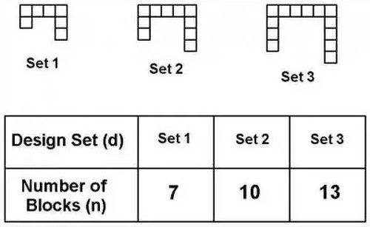

Reference: Hannigan, R., n.d. Found at: https://www.teacherspayteachers.com/Product/8th-Grade-Functions-Pre-Assessment-2223379

Linear vs. Non-Linear
(Found on TeachersPayTeachers)
Summative & Formative
Used as Pre-Assessment
The functions represented by these graphs are linear.

The functions represented by these graphs are non-linear.

- Explain how you can determine if a function is linear or non-linear by looking at the graph.

These sequences represent relationships that are linear.

2, 5, 8, 11, . . . 13, 7, 1, -5, -11, . . . 4, 8, 12, 16, 20, . . . 2, 4, 6, 8, . . .

These sequences represent relationships that are non-linear.

2, 4, 8, 16, 32, . . . 1, 4, 9, 16, 25, . . . 100, 95, 85, 70, 50, . . . 1, 1, 2, 3, 5, . . .

- Explain how you can determine if a sequence is linear or non-linear.

input | output
x | y
-2 | -7
-1 | -3
0 | 1
1 | 5
2 | 9
3 | 13

input | output
x | y
-2 | -17
-1 | -11
0 | -5
1 | 1
2 | 7
3 | 13

input | output
x | y
-2 | 12
-1 | 10
0 | 8
1 | 6
2 | 4
3 | 2

These tables represent functions that are non-linear.
input | output
x | y
-2 | -7
-1 | -3
0 | 2
1 | 8
2 | 15
3 | 23

input | output
x | y
-2 | 4
-1 | 1
0 | 0
1 | 1
2 | 4
3 | 9

input | output
x | y
-2 | 2
-1 | 0
0 | 0
1 | 2
2 | 6
3 | 12

- Explain how you can determine if a function is linear or non-linear by looking at an input-output table.

These equations represent functions that are linear.

y = -3x y = 9 y = 2x – 5 y = ½x

These equations represent functions that are non-linear.

y = x 2 y = 3x2 + 4 y = 2x y = 5/x

- Explain how you can determine if a function is linear or non-linear by looking at the equation of the function.

Name Answer Key Date Period

Linear vs. Non-Linear – ANSWER KEY
The functions represented by these graphs are linear.

The functions represented by these graphs are non-linear.

- Explain how you can determine if a function is linear or non-linear by looking at the graph. A linear function will form a straight line when graphed. A non-linear function forms something other than a straight line when graphed.

These sequences represent relationships that are linear.

2, 5, 8, 11, . . . 13, 7, 1, -5, -11, . . . 4, 8, 12, 16, 20, . . . 2, 4, 6, 8, . . .

These sequences represent relationships that are non-linear.

2, 4, 8, 16, 32, . . . 1, 4, 9, 16, 25, . . . 100, 95, 85, 70, 50, . . . 1, 1, 2, 3, 5, . .
.

- Explain how you can determine if a sequence is linear or non-linear.

A linear sequence has a common difference between the terms in the sequence – it has a constant rate of change. A non-linear sequence has varying differences between terms in the sequence – it has a varying rate of change.

These tables represent functions that are linear.
input | output
x | y
-2 | -7
-1 | -3
0 | 1
1 | 5
2 | 9
3 | 13

input | output
x | y
-2 | -17
-1 | -11
0 | -5
1 | 1
2 | 7
3 | 13

input | output
x | y
-2 | 12
-1 | 10
0 | 8
1 | 6
2 | 4
3 | 2

These tables represent functions that are non-linear.
input | output
x | y
-2 | -7
-1 | -3
0 | 2
1 | 8
2 | 15
3 | 23

input | output
x | y
-2 | 4
-1 | 1
0 | 0
1 | 1
2 | 4
3 | 9

input | output
x | y
-2 | 2
-1 | 0
0 | 0
1 | 2
2 | 6
3 | 12

- Explain how you can determine if a function is linear or non-linear by looking at an input- output table.

A linear function has output values that increase or decrease at a constant rate as the input values increase or decrease at a constant rate. A non-linear function has output values that increase or decrease at a varying rate as the input values increase or decrease at a constant rate.

These equations represent functions that are linear.

y = -3x y = 9 y = 2x – 5 y = ½x

These equations represent functions that are non-linear.

y = x² y = 3x² + 4 y = 2^{x} y = 5/x

- Explain how you can determine if a function is linear or non-linear by looking at the equation of the function.

The linear functions do not have any exponents with the x-term or an x that is the exponent. The linear functions all are in the form of y = mx + b (although for some of them the m or b value is 0). None of the linear functions have something divided by x.

Reference:
Susan’s Math Stuff, n.d. Found at: https://www.teacherspayteachers.com/Product/Linear-vs-Non-Linear-1517619

Pre-Assessment Results
I broke each answer down into two or three parts, for instance question 4 had three parts to its answer but the others had only two. If the students answered close enough to what I was looking for, I gave them a point for that answer. If it seemed the student did not have the important information in their answer, they did not get a point for that. For instance, in question 4, one of three parts was knowing linear functions are all in y=mx+b form, but only one student made mention of this. My results are as follows: So, this is your test data results? I’m not sure if I understand. This is a beautiful test and very well done. I like to use the same pre-test as the summative test to compare the scores. That tells me if I need to cover any specific areas.
1/16 recognized linear functions in an equation as being in y=mx+b form
2/16 recognized non-linear tables had varying rates of change for output, but input rate of change stayed the same.
3/16 recognized none of the linear functions in an equation had something divided by “x”.
4/16 recognized linear functions in a table had output values that had a constant rate of change as the input values had a constant rate of change also.
6/16 recognized linear functions in an equation do not have any exponent with the x-term or “x” as an exponent.
10/16 recognized non-linear graphs as something other than a straight line.
13/16 recognized linear functions when graphed, have a straight line; a linear sequence has a constant rate of change; and non-linear sequence as having varying rates of change.
Section 1: Lesson Preparation

Teacher Candidate Name:
Grade Level: | 8th
Date: | February 18, 2019
Unit/Subject: | Functions
Instructional Plan Title: | Linear or Nonlinear, Function or Not Function?
Lesson Summary and Focus: | Students will review what a function is and work toward recognizing what linear and nonlinear functions and nonfunctions are. Students will use real world examples to identify linear and nonlinear functions and nonfunctions.
Classroom and Student Factors/Grouping: | There are two students with IEPs in this eighth grade Algebra class. Some students like to be a little chatty and they all seem to enjoy games.
National/State Learning Standards: | What is your state standard? I need to see it spelled out so I can determine if everything aligns.

© 2018. Grand Canyon University. All Rights Reserved.

Alabama Course of Study Standards:
Mathematics Are these your standards? Where are the standard numbers? Do you plan on addressing all of these standards in a 50-minute class?
Understand that a function is a rule that assigns to each input exactly one ouput. The graph of a function is the set of ordered pairs consisting of an input and the corresponding output. (Function notation is not required in Grade 8). [8-F1]
Compare properties of two functions, each represented in a different way (algebraically, graphically, numerically in tables, or by verbal descriptions). [8-F2]
Interpret the equation y=mx+b as defining a linear function whose graph is a straight line; give examples of functions that are not linear. [8-F3]
Specific Learning Target(s)/Objectives: | Using a Frayer Model, students will demonstrate their understanding of the definition of a function. Please review my announcement and posts on creating measurable objectives. For this objective I will use the ABCD model to provide a measurable objective example:  A=students will  B=demonstrate the definition of a function  C=using the Frayer Model  D= You want to include how you will measure. You can measure with “2 sentences”, at 80% accuracy or 3 out of 5 steps correct.  Using a Frayer Model, students will demonstrate their understanding of the definition of a function in 3 out of 5 steps correct.  Given different forms of a function, students will accurately label them as function or not a function.  Given real world examples and algebraic examples, students will be able to identify whether it is a linear function, nonlinear functions, linear nonfunctions and nonlinear nonfunctions.

© 2018. Grand Canyon University. All Rights Reserved.

Academic Language | Students will use the guided notes from previous lesson to fill in a Frayer Model. The students will also play a game to help reinforce their vocabulary knowledge.  Content area vocabulary words are different than academic language. Please review this site or research further for math academic language. https://scale.stanford.edu/teaching/pact/supporting-documents/single-subjects/academic-language  Function Relation Domain Range  Vertical line test Linear Nonlinear
Resources, Materials, Equipment, and Technology: | LinerNonlinerVsFunctionNotafunction I have, who has?  Function or Not a Function Venn Diagram White board  Document camera  Will you be passing out a Frayer Model worksheet?

© 2018. Grand Canyon University. All Rights Reserved.

Section 2: Instructional Planning

Anticipatory Set You may want to include your pre-test here. The Anticipatory Set is where you want to establish a hook for your students on the upcoming instruction. How to Hook Your Students Instantly: the Anticipatory Set – Complete Literature  - I will provide students with different forms of functions or nonfunctions and draw a Venn Diagram on the board labeled as Function or Not Function.  - I will ask the students to individually go to the board with their form and place it where they think it goes and give an explanation as to why. Is this where students will be given real world examples?  - Through this activity, I will pick up on any connections the students make to vocabulary words and emphasis those connections. Will this be using the Frayer Model? | Time Needed
Multiple Means of Representation  - Students will use their guided notes from the previous day to fill in a Frayer Model to get a better understanding of what a function is.  Representation Section - I do – Teacher does the thinking and teacher does the work  This section is also known as the modeling section. This is where you are teaching your students any and all skills, steps, and strategies that you want for this specific task.  Engagement - We do section is where you will spend the majority of your time with your students.  Expression – They do This is the final step before students move into the independent work stage.  Explain how you will differentiate materials for each of the following groups: Keep in mind if you are providing anything to one group you need to offer to all students. That ensures you are not signaling out any one group of students.  - English language learners (ELL):  Provide sentence starters and examples of what is expected.  - Students with special needs:  Provide sentence starters and examples of what is expected.  - Students with gifted abilities:  Ask for 2 real world examples of a function.  - Early finishers (those students who finish early and may need additional resources/support):  Ask students to come up with their own equations. | Time Needed

© 2018. Grand Canyon University. All Rights Reserved.

Multiple Means of Engagement  - I will use I have, who has? game for students to practice vocabulary  - Using real world examples of functions, the students will play Four corners with the labels linear function, nonlinear function, linear nonfunction and nonlinear nonfunction. Love it, good instructional strategies.  Explain how you will differentiate activities for each of the following groups:  - English language learners (ELL):  Read card to student before the “I have/ who has?” game begins and have a peer partner help student with their thoughts before moving to the corner.  - Students with special needs: You may not have time to read cards individually, however, that will be helpful for this population.  Read card to student prior to beginning “I have/ who has?” game and making sure they can say it out loud and making sure they know what they should be listening out for.  - Students with gifted abilities:  - Early finishers (those students who finish early and may need additional resources/support): | Time Needed

© 2018. Grand Canyon University. All Rights Reserved.

Multiple Means of Expression  Students will participate in think-pair-share work and whole class discussion for me to determine their understanding of the days lesson and to adjust the next day’s lesson.  Explain if you will differentiate assessments for each of the following groups:  - English language learners (ELL):  Allow students sentence starters and to use peer helpers for transcription help.  - Students with special needs:  Allow students to offer verbal explanation when necessary and have someone transcribe their answers for them. If students are working in a group maybe just assign someone to do the writing. Rather than signaling out students to speak clearly.  - Students with gifted abilities:  Ask them to give three more examples with explanation.  - Early finishers (those students who finish early and may need additional resources/support):  Ask them to work on Study Island or draw real world examples. I love this idea we have to always have something special for this group of students. | Time Needed

© 2018. Grand Canyon University. All Rights Reserved.

Extension Activity and/or Homework  Lastly, students will Think-Pair- Share, alternating their partners within their seated groups. to answer “Function/ Not a Function and Linear/ Non-Linear” worksheet to further their ability to identify linear and non-linear functions and linear and non-linear nonfunctions. | Time Needed
Rationale/Reflection

- Four Corners has students critically thinking prior to engaging and collaborating with others to share their thought processes and ideas. This promotes listening and debating of others’ ideas while being respectful.
- Frayer Model strengthens the student’s creativity and critical thinking by having them take information from one source and displaying it in other ways. By including examples and nonexamples, students are having to critically think about what the definition encompasses and excludes.
- I have/ who has? requires students to communicate and collaborate to find the correct I have for the Who has questions. This allows students to practice their academic language skills also. Don’t forget about think pair share

© 2018. Grand Canyon University. All Rights Reserved.

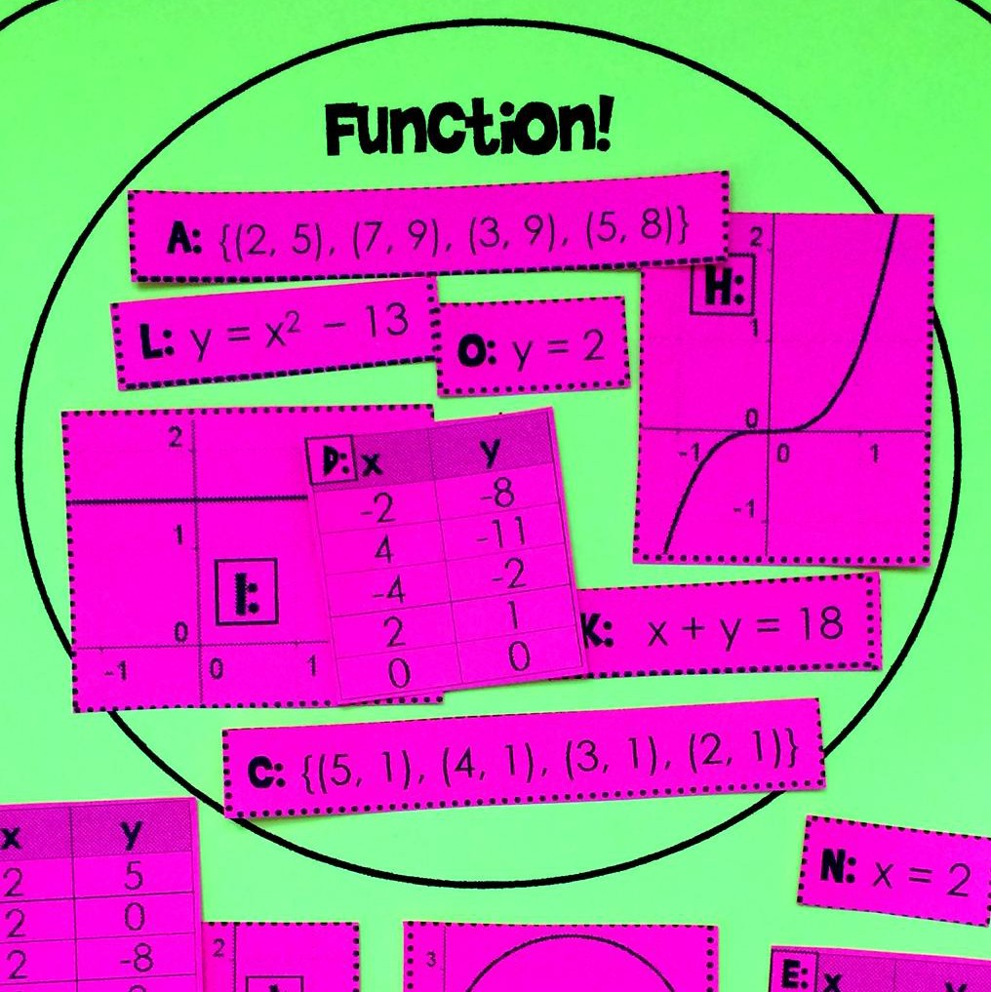

Function or Not?
Venn diagram sorting activity

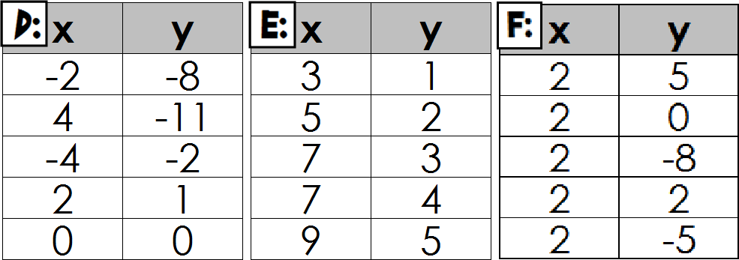
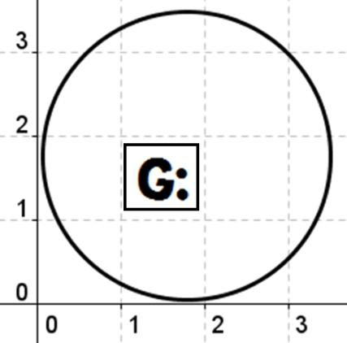
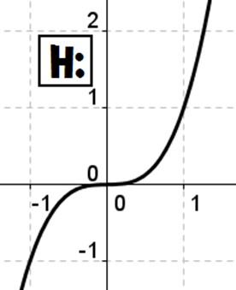
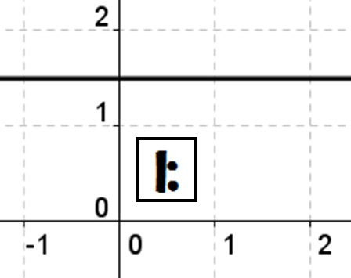
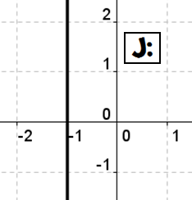
Directions:
Cut out the relations below and paste each one on to the Venn diagram. If a relation is a function, it gets to go in the functions inner circle!

Remember…
Functions have only one output (y) for every input (x).

A: | {(2, | 5), (7, 9), (3, 9), (5, 8)} | K: | x + y = 18 | N: | x = 2
B: | {(3, | 5), (2, 5), (5, 8), (3, 1)} | L: | y = x2 − 13 | O: | y = 2
C: | {(5, | 1), (4, 1), (3, 1), (2, 1)} | M: | x = y2 + 1

Function!

Relation

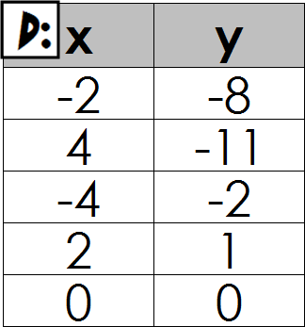
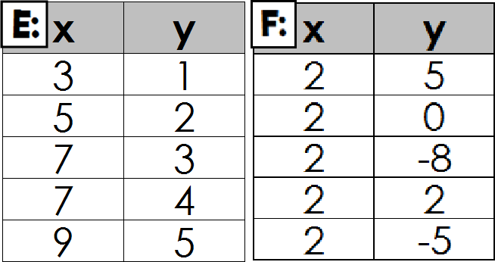
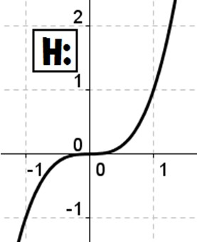
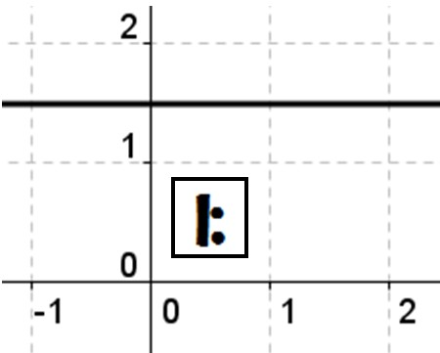
Answer Key:

Function!
A: {(2, 5), (7, 9), (3, 9), (5, 8)}

C: {(5, 1), (4, 1), (3, 1), (2, 1)}
O: y = 2

K: x
L: y = x2 − 13
+ y = 18

B: {(3, 5), (2, 5), (5, 8), (3, 1)}

N: x = 2

Relation
M: x = y2 + 1

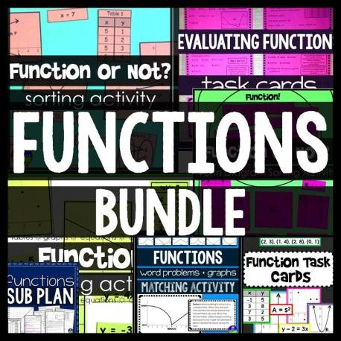

Rebecca Meyer

Surfer Kids ClipArt

with Scaffolded Math and Science

teacherspayteachers.com/Store/Scaffolded-Math-And-Science

Review for credits

2. What are some characteristics of equations that would make them NON-LINEAR?

Relation | State whether the relation is a function or not. Justify your response. | State whether the relation is linear or not. Justify your response.
3. y = 7x
4. y = 5 + 3
x
5. y = x2 − 4
6. y = 1 x + 2
3
7. y ² = x
8. y = 8
9. x2 + y2 = 9
10. y = x3

y2 or √x

2. What are some characteristics of equations that would make them NON-LINEAR?

x or y taken to a power greater than one x in the denominator of a fraction.

Relation | State whether the relation is a function or not. Justify your response. | State whether the relation is linear or not. Justify your response.
3. y = 7x | Function;  No y2 or √x so each input will have one output. | Linear;  In the form y=mx+b
4. y = 5 + 3  x | Function;  No y2 or √x so each input will have one output. | Non-Linear;  x in the denominator of a fraction
5. y = x2 − 4 | Function;  No y2 or √x so each input will have one output. | Non-Linear;  x taken to power greater than 1
6. y = 1 x + 2  3 | Function;  No y2 or √x so each input will have one output. | Linear;  In the form y=mx+b
7. y ² = x | Not a Function;  Equations with y2 will have multiple outputs for each input. | Non-Linear;  y taken to power greater than 1
8. y = 8 | Function;  No y2 or √x so each input will have one output. | Linear;  In the form y=mx+b
9. x2 + y2 = 9 | Not a Function;  Equations with y2 will have multiple outputs for each input. | Non-Linear;  x and y taken to powers greater than 1
10. y = x3 | Function;  No y2 or √x so each input will have one output. | Non-Linear;  x taken to power greater than 1

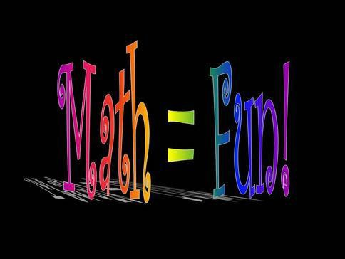
I Have, Who Has Linear Functions
Ambie Watson: Get Your Math Together
2017

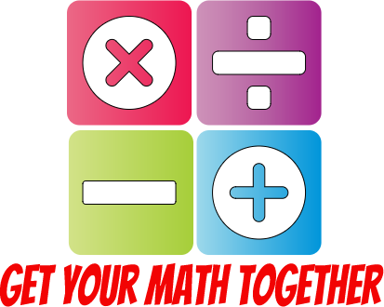
Copyright 2017 Get Your Math Together
Interested in more of my products? Check out my store on TPT!

Directions: Print pages 3-8 and cut each card so each student will have “I HAVE” at the top and “WHO HAS” at the bottom. Pass the cards out in random order. Card 1 will stand and say “I have y=7x-6. Who has the slope of my line?” The person with “m = 7” will stand and read their card and the game will continue.
The last card should link back to the person who started the game.

I HAVE  y=7x-5 | I HAVE  M = 7
WHO HAS  The slope of my line? | WHO HAS  The y-intercept of 4x+y=10?
I HAVE  10 | I HAVE  y=4x+2
WHO HAS  The equation of a line that has a slope of 4 and y-intercept of 2? | WHO HAS  The equation of a line with a slope of -1/3 and a y-intercept of 5?

I HAVE  y=-1/3x+5 | I HAVE  (0, 5)
WHO HAS  The y-intercept of my line  (y=-1/3x+2) | WHO HAS  The equation of a line that has a slope that is the absolute value  of -3?
I HAVE  y=3x-5 | I HAVE  (0, -5)
WHO HAS  The y-intercept of my line (y=3x-5) | WHO HAS  The definition of slope?

I HAVE  The change of the vertical distance divided by the change of the horizontal distance. | I HAVE  y=5x+4
WHO HAS  The equation with a slope of 5? | WHO HAS  The y-intercept of my equation (y=5x+4)
I HAVE  (0, 4) | I HAVE  The set of all input values  (x-values)
WHO HAS  The definition of domain? | WHO HAS  The range for the following function… (2, 7) (5, 9) (-1, 4) (-8, 2)?

I HAVE  2, 4, 7, & 9 | I HAVE  A table
WHO HAS  One way we can represent a function? | WHO HAS  The definition of a function?
I HAVE  every input value has exactly one output value. | I HAVE  Where a graph intersects the y-axis.
WHO HAS  The definition of a y-intercept? | WHO HAS  The domain of the following function… (4, -6) (2, -7) (3, 18)  (20, -1)?

I HAVE  2, 3, 4, & 20 | I HAVE  y=mx+b
WHO HAS  Slope-intercept form? | WHO HAS  The formula for finding slope?
I HAVE  𝑦₂ − 𝑦₁  𝑥₂ − 𝑥₁ | I HAVE  (0, -7)
WHO HAS  A point that is on the line: y=-10x-7? | WHO HAS  A point that is on the line 2x+y=-3

I HAVE  (1, -5) | I HAVE  M = −9  4
WHO HAS  The slope of a line that passes through (0, 7) & (4, -2)? | WHO HAS  The slope of a line that passes through (-7, 8) & (0, 12)?
I HAVE  M = 4  7 | I HAVE  y=-22x+10
WHO HAS  The equation of a line that has a  slope of -22? | WHO HAS  The equation of a line with a slope of 7 & a  y-intercept of (0, -6)?

