- Course and grade level (i.e., 11th grade English)
- A list of the students with pseudonyms (do not use their names)
- Gender Labels
- (gifted, ELL, Spec Ed, 504) with explanations as to the modifications made for those identified areas
- Characteristics (likes/dislikes of the student, work ethic, etc.)
- Test scores(any classroom, school, district, state test scores)
- Current grade in course

In 500-750 words, address the following:
- Using your content area as a guide, identify three students in the class for whom lesson modifications could be created in your planned unit, and describe their exceptionalities.
- Based on your modifications, do you believe the identified students will be able to successfully complete the measurable elements of the objectives of your unit?
- Explain your response in detail and defend your decisions. Discuss the effect teaching both the original activities as well as the modified activities might have on completing your unit within the planned class time.
- How might a pre-assessment support the diverse student needs in this class?
- During unit activities, how might formative assessments inform how you will meet the needs of the diverse students in this class?
- How might technology be used to address students' diverse learning preferences?
- If there are no students with exceptionalities, collaborate with the classroom teacher to create three to add to the profile for this and the benchmark assignment.

Excellent chart, I personally prefer Excel charts to list student data. I think every teacher should set up a chart on every class at the beginning of the year. You can collect data, monitor progress and in Excel do comparison line graphs. Your Section I Unit is for 8th grade and this is a 7th grade class.
Thank you for describing your instructional strategies for your class. Your modifications for the identified students are planned-out well to instruct math that requires attention to details and specific steps which could be difficult for some of your students. I don’t want you to modify too much with a full class or you will wear yourself out sooner than later. Be careful not to cater to students too much, there are other resources on campus to assist. The details of your assessments and strategies were addressed and specific. In our class discussions, resources of group work, jigsaw, various questioning techniques and project-based learning are ways a teacher can differentiate their instruction. Flipping the classroom by assigning video, written or audio lectures as homework. For your population it may have been beneficial for you to research differentiated instruction or review sources online that are designed for troubled students.
Cindy

7th Grade PSSA | Period 1 | MP1 (%) | Grade | MP2 (%) | Grade | Feb. 7 | MP3 (%)
Basic | Student A | 95 | A | 97 | A | 93 (A) | 94
Below Basic | Student B | -------- | ---- | 81 | C | 75 (C) | 85
Below Basic | Student C | 81 | C | 72 | D | 72 (D) | 73
Basic | Student D | 81 | C | 85 | B | 79 (C) | 87
Basic | Student E | 83 | B | 68 | D | 89 (B) | 84
Basic | Student F | 78 | C | 73 | D | 83 (B) | 73
Proficient | Student G | 95 | A | 98 | A | 91 (B) | 93
Basic | Student H | 94 | A | 99 | A | 93 (A) | 93
Below Basic | Student I | 85 | B | -------- | ------ | -------- | --------
Below Basic | Student J | 75 | C | -------- | ------ | -------- | --------
Below Basic | Student K | 79 | C | 81 | C | 81 (C) | 93
Proficient | Student L | 99 | A | 93 | A | 96 (A) | 96
Below Basic | Student M | 91 | B | 84 | B | 87 (B) | 89
Below Basic | Student N | 100 | A | 100 | A | 97 (A) | 96
Below Basic | Student O | 67 | D | 69 | D | 69 (D) | 85
Basic | Student P | 98 | A | 100 | A | 97 (A) | 97
Below Basic | Student Q | 79 | C | 75 | C | -------- | ------
Basic | Student R | 85 | B | 79 | C | 80 (C) | 79
No Score | Student S | 86 | B | 66 | D | 78 (C) | 82
No Score | Student T | 91 | B | 94 | A | 96 (A) | 93
Basic | Student U | 87 | B | 71 | D | 83 (B) | 87
Below Basic | Student V | 83 | B | 82 | C | 80 (C) | 79
Basic | Student W | 78 | C | 88 | B | 87 (B) | 85
 |  | Totals | A = 6 | Totals | A = 7 |  | Totals
 |  |  | B = 8 |  | B = 3
 |  |  | C = 7 |  | C = 5
 |  |  | D = 1 |  | D = 6
 |  |  | F = 0 |  | F = 0
Lesson Modifications
In the class profile, there are several students with an established Individualized Education Plan (IEP). I will choose students B, I, and Q and discuss how I would modify my lesson plans and accommodate their IEP requests. In this class profile, I can see that a majority of students scored Basic (9 students) and Below Basic (10 students) and only two students scored Proficient on their 7th grade Pennsylvania System of School Assessment (PSSA) Exam. All of the IEP students scored Below Basic. Overall, I will be approaching the whole class with a varied approach with visuals, limited writing and reading, and differentiated tasks.
First, I looked for commonalities between my chosen IEP students: using the school agenda, extended time for tests/assignments, graphic organizers, accept verbal responses instead of written, and repetition of previously taught and learned material. Luckily, I already intend to purposefully use the school’s agenda, utilize an Interactive Notebook system, and continuously build on and review cumulative math concepts.
Next, I will address the extended work times and verbal responses. For some kids, test anxiety is a real struggle. I would explain that I “quiz” them every day with entry/exit tickets, Kahoot games, or just asking them questions. Just because it’s on paper, shouldn’t increase your blood pressure. I know how amped up kids can get about a test because it’s graded and they’re concerned about getting good grades and keeping up a GPA. I often use the analogy of holding on tightly to a rock in your fist. The more you squeeze, the harder it is to get the rock. Relax, and open your fingers, and you can easily reach the rock. Your brain is very much the same way. You need to relax and rely on the clues I’ve left you in the Interactive Notebook. There are lots of little funny sayings or bright colors and shapes that can trigger loads of information. Written responses can be a little tricky, but in math, I would rely on the grasp of the overall concept. I think typos here are there are inevitable. If these students continually struggle with the written answer, then they should be able to verbally explain the process to me. Then the dropped sign or miss calculation can be looked over.
I intend to give a learning preference survey once at the beginning of the year and again after winter break to look for changes. Performing a learning preference survey twice a year allows the student to see if they have shifted. This survey will be about 15 to 20 questions and will ask them their preferred method of engaging in activities. These questions will address three learning strategies: video, auditory, and kinesthetic. Here is an example of learning style survey from www.GADoE.org and has a description of the various learning styles for the student to read after they find their results.
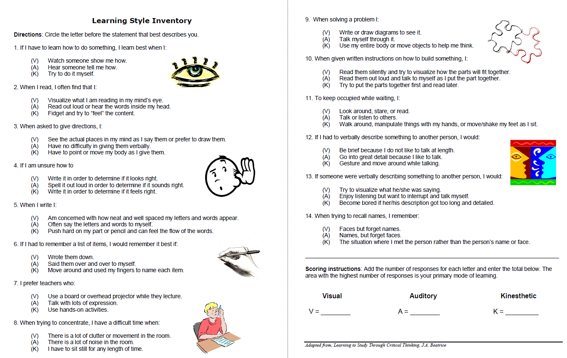

Formative assessments are crucial for monitoring progress towards the standard. Giving them frequently whether formally or informally, gives the clearest picture of their comprehension. Pre-tests such as the entry ticket gauges their background knowledge or to review any previously taught content. Class/group assignments and discussions also tell me where the student may need some clarity with a follow up example or some one-on-one instruction at the end of the period or during study hall.
Technology is ingrained in our everyday lives and should be used in the classroom. Kahoot is a fun way to formatively assess students. Other Learning Management Systems (LMS) like Google Classroom or Schoology give the student structure to continue learning at home on a computer. In the classroom, there are many other teaching strategies that involve tech. These can range from high tech like iPad apps and graphing programs to simple setups like a document/computer screen projector. Students that need these lesson modifications can benefit from the anonymity of Kahoot games. The other students can’t see who’s answering the questions incorrectly, but the teacher can and adjust accordingly. Their confidence and self-esteem are protected.

References

Learning Style Inventory (n.d.) Retrieved from https://www.gadoe.org/Curriculum-Instruction-and-Assessment/Special-Education-Services/Documents/IDEAS%202014%20Handouts/LearningStyleInventory.pdf

